Assignment 15

# DL29A.py

## Original Output

## New Output

## Modification to Code

target = data.filter(ImageFilter.CONTOUR)

# DL29B.py

## Original Output

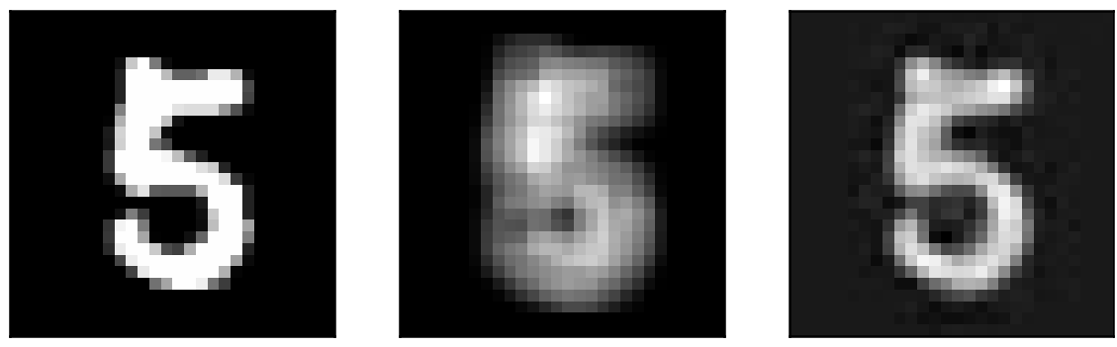

## New Output

## Modification to Code

No changes to code. Input file, DL29Aepoch1.zip modified by aforementioned DL29A.py changes (using COTOUR instead of BLUR).

# DL29C.py

## Original Output

## New Output

## Modification to Code

Changed fuzzy as follows:

fuzzy = torchvision.transforms.functional.solarize(torch.randn(1, 1, 3, 3), threshold=0.4)

## Comments

As you can observe above, changing the kernel to use solarize inverts the colors making lighter pixels darker and darker pixels lighter. It does not help with denoising as much since the resulting pixels are proportionate to that of the original image. Adjusting the threshold, however, does enhance (as well as diminish) the picture significantly by reducing/increasing noise. Here are some of the results for different threshold values, for reference.

### Threshold=0.1

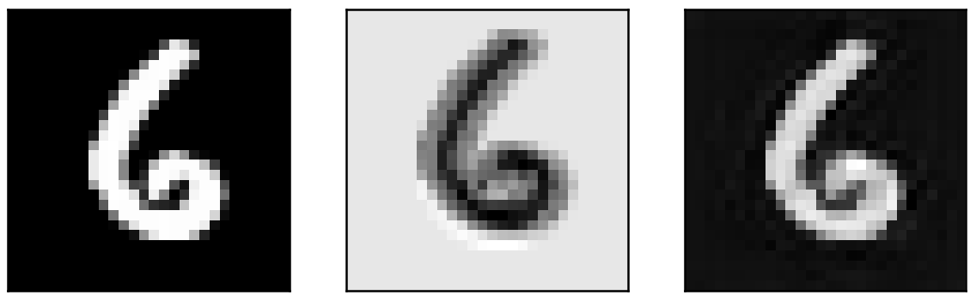

### Threshold=0.2

### Threshold=0.6

### Threshold=0.9